

Sponsorship

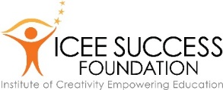
Contact: Lucinda Presley,
Executive Director
lucinda.presley@gmail.com


____________________________________________________________

Invest in the Future

Bring a hands-on exhibit to Palestine which is based on the world-famous Exploratorium in San Francisco, CA. This exhibit, Curious, promotes creative and innovation thinking skills that are important for all ages.
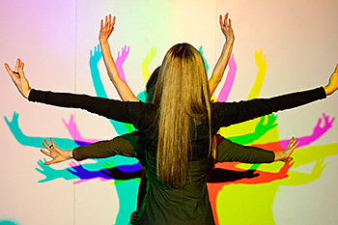
It is an exciting hands-on exhibit designed for individuals and families, for anyone who has ever been curious. It will engage preschoolers through adults in a fun, engaging, and, ultimately, educational format.

The exhibit will be open Fridays through Sundays October 10, 2015, through January 3, 2016 (closed Christmas Day and “Imagination is more important
New Year’s Day). It will be available Mondays through than knowledge.” - Einstein
Thursdays for group visits and school field trips.

Among the special opportunities Curious will offer are:
- Programs: with nationally-known personalities
- Family days: exciting and engaging activities for families to do together
- Adult programs: interesting and entertaining events
- An exhibit store: intriguing and engaging activities and gifts in a broad range of prices.

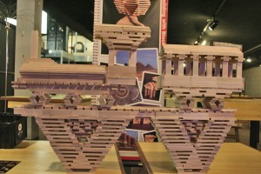
Curious is building on the impressive success of the Philip Beesley Living Architecture exhibit recently installed at the Palestine Mall. Curious is designed to address the vital need to develop innovation thinking skills in students through adults.

Your support will provide school children the opportunities they need to encourage their interest in Science, Technology, Engineering, the Arts, and Math (STEAM). Your support will directly impact the lives of Palestine and Anderson County youth. Your support will help us build the leaders of tomorrow

“I have not special talents. I am only
Passionately curious.” - Einstein

Join us in a stellar opportunity for Palestine… come be Curious!
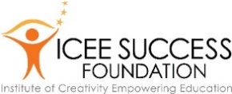

Why this is Important
_____________________________________________________________

Innovation and Maximizing Brain Performance
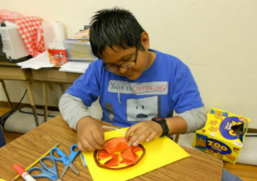
- Nationally-recognized researchers, educators, businesses, and governmental studies say that the United States’ future in the global economy could be significantly impacted by how well today’s young people are taught to think innovatively.
- Brain studies show that, for all ages, looking at things in a new way, putting ideas together, and solving problems innovatively makes the brain healthier and more productive

About ICEE Success – a Palestine-based initiative:
- Integrating Curiosity and Learning: ICEE (Institute where Creativity Empowers Education) Success is devoted to positively impacting the future by promoting opportunities to increase vital creative and innovation thinking skills in students and adults of all ages.
- Partnership with Palestine ISD:
  - In schools, ICEE promotes creative and innovation thinking tied with standards-based learning in partnership with schools, districts, and Texas Education Agency (TEA) region service centers. A primary partner is Palestine ISD. Other East Texas partners include Caldwell Elementary Arts Academy in Tyler ISD and TEA Region VII Education Service Center.
  - ICEE provides: 1) curriculum development and classroom implementation; 2) educator professional development; and 3) research in collaboration with local, state, national, and international partners. Data and anecdotal information validate the success of this work.
- Museums: In work with museums, exhibits, and after-school programming, ICEE integrates play, curiosity, learning, and creative/innovation thinking. Success is seen in last year’s Philip Beesley Living Architecture exhibit, which drew a large number of visitors of all ages, who reported having great experiences at the exhibit. ICEE works with a number of world-class museums nationally.

Sponsorship Levels
____________________________________________________________

In appreciation for your support, the following benefits are available.
Levels of Giving and Benefits
- Visionary ($10,000 and above)
  - Priority placement of your logo on Curious website, banners, all printed and digital materials, and in presentations about Curious
  - Special event for your group at Curious exhibit
  - 64 tickets to exhibit
  - Plus all opportunities listed below
- Innovator ($5,000 - $9,999)
  - Placement of your logo on Curious website, banners, all printed and digital materials and in presentations about Curious
  - Special table for 8 at special events
  - 32 tickets to exhibit
  - Plus all opportunities listed below
- Inventor ($1,000 - $4,999)
  - Special recognition at all Curious special events
  - Invitation for 4 to special events
  - Skyping opportunities available for selected ICEE state, national, and international collaborators
  - 15 tickets to exhibit
  - Plus all opportunities listed below
- Brainstormer ($500 - $999)
  - Invitation to small social events with important visiting dignitaries
  - Recognition on Curious website with small logo
  - 8 tickets to exhibit
  - Plus all opportunities listed below
- Problem-identifier ($250 - $499)
  - Recognition in press release
  - Free group tour with activity for group of 20 with reservation
  - Unlimited visits to exhibit for 4
  - Invitation to preview and special events
  - Priority admission to exhibit
- Classroom Sponsor ($150 - $249)
  - $150 pays for a classroom of 25 students
  - Recognition in education publicity and at sponsored classroom’s visit
  - Unlimited visits to exhibit for 4
  - Invitation to preview and special events
Invest in the Future
_____________________________________________________________

Supporting the Curious exhibit brings world-class exhibits and programming to Palestine. It is a meaningful gift to the community.
Support Curious Today!
Yes! I want to bring quality exhibit and program to Palestine.

Visionary ($10,000 and above)
Innovator ($5,000 - $9,999)
Inventor ($1,000 - $4,999)
Brainstormer ($500 - $999)
Problem-identifier ($250 - $499)
Classroom Sponsor ($150 - $249)

________________________________________________________________________
Name

________________________________________________________________________
Address

________________________________________________________________________
City State Zip

________________________________________________________________________
Email

________________________________________________________________________
Phone

_______________________________________________________________________
Signature

Checks should be payable to ICEE Success Foundation.
Your contribution is tax-deductible.

Thank you for making a difference.

